**B.R.A.C.T’S**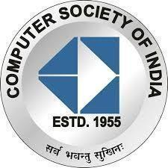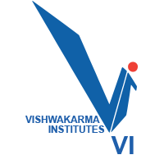

**Vishwakarma Institute Of Information Technology, Pune**

**Report on: A Look Inside With CSI VIIT**

**Organized by**: Computer Society of India, VIIT Pune Student Branch 2021-2022.

**Date**: 21st – 24th February, 2022

**Platform: Cisco Webex**

**The Start (Up)**

**21st February 2022:**

The first interactive session of the 4-day-long event “A Look Inside! – with CSI” was “The Start (Up)” focused on Start-Ups and Entrepreneurship. Mr. Akash Joshi (B.Tech, Entrepreneur, Public Speaker) was the speaker of the session. Open-source projects and development were also discussed in the session as the speaker is an active open-source developer as well.

The session began at 4:00 pm with a warm welcome and introduction of the speaker by the anchor Vaishnavi Pophale, the joint technical head at CSI-VIIT. The speaker began his talk by discussing how he was more into programming and web development than start-ups and entrepreneurship in his early engineering days. He also discussed how he got his first job in the third year of engineering in web development by learning the latest web technologies which were too new to draw people’s attention. He advised students and young entrepreneurs not to be afraid of taking bold decisions and choosing the unexplored path having great potential. He then talked about the importance of working on more and more projects throughout your engineering as they are extremely important from employers' perspectives and draw their attention the most. He also elaborated on his Open-Source project contributions and how it was a great learning experience for him and brought him a lot of networking and job opportunities. He said that he began open-source contributions in his third year of engineering and by the time this session is being conducted, he has worked on over 120 projects. Finally, he revealed his multiple entrepreneurial ventures which he began in his fourth year of engineering. He talked awhile about the experiences and the learning outcomes he got from each one of those ventures.

The entire session was immensely interactive and received a great response from the audience with the participants’ count reaching up to 62. The talk session concluded with a vote of thanks by the anchor Vaishnavi Pophale to the speaker and all the honorable dignitaries of CSI-VIIT.

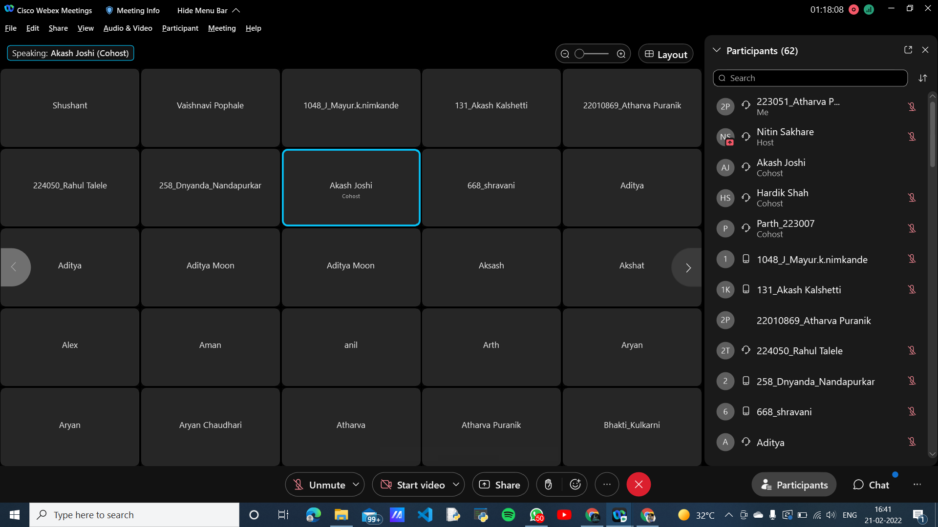

**Corporate World**

**22nd February 2022:**

It was the second talk session of the 4-day event “A Look Inside! - with CSI” that, as the name suggests, focused on various aspects and experiences of the corporate world. The speaker, Mr. Chetan Shetty, is an engineering graduate from COEP and has an amazing experience of over 30 years in the corporate world. Along with working in a corporate job, he also pursued his interests like storytelling and public speaking.

The session was anchored by Parth Bhosle, the joint technical head of CSI-VIIT, and began at 4:00 pm with a warm welcome and introduction of the speaker by the anchor. The entire talk session was based on a Himalayan adventurous trek of the speaker along with his family and friends to the base camp of Mt. Everest. The speaker related his experiences of the trek to the things one can experience in a corporate world and thus made the entire talk session uniquely interesting. He elaborated on the various things he experienced, and the people he met throughout the trek which taught him many important life lessons and how he applied those learnings in his corporate life and saw gradual changes. Being a public speaker, he was easily able to connect with the audience and kept them engaged and interactive throughout the session. He also shared his views on the parent-child relationship.

Finally, he talked about his entrepreneurial ventures and told some of his entrepreneurship principles. The session ended with a grateful vote of thanks by the anchor Parth Bhosle to the speaker and the honorable dignitaries of CSI-VIIT. The session received an amazing response from the students with a staggering participants count of 74.

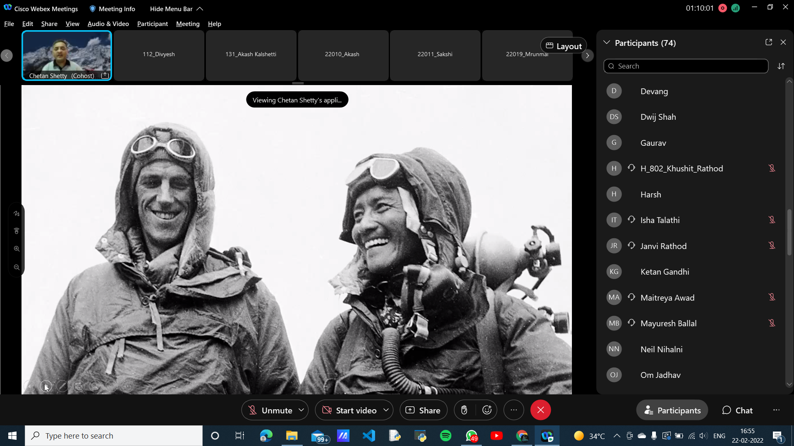

**“The Next Degree”**

**23rd February 2022:**

“The Next Degree” was our theme for the third day. The major purpose of the talk was to guide the audience regarding the various options that students can explore after the completion of their bachelor’s. Our speaker Mr. Geet Shingi, M.S. from the University of Southern California, threw light on higher education after engineering. He talked about his experience of getting through the examinations and visa application process. As he himself had gone through all the proceedings for pursuing a master’s, he focused on the master’s topic. The session was very informative to students, and Mr. Geet was successful in answering the majority of the doubts of the participants. He also provided personalized advice for all students at any level of their education. Overall, the session was greatly appreciated by the participants.

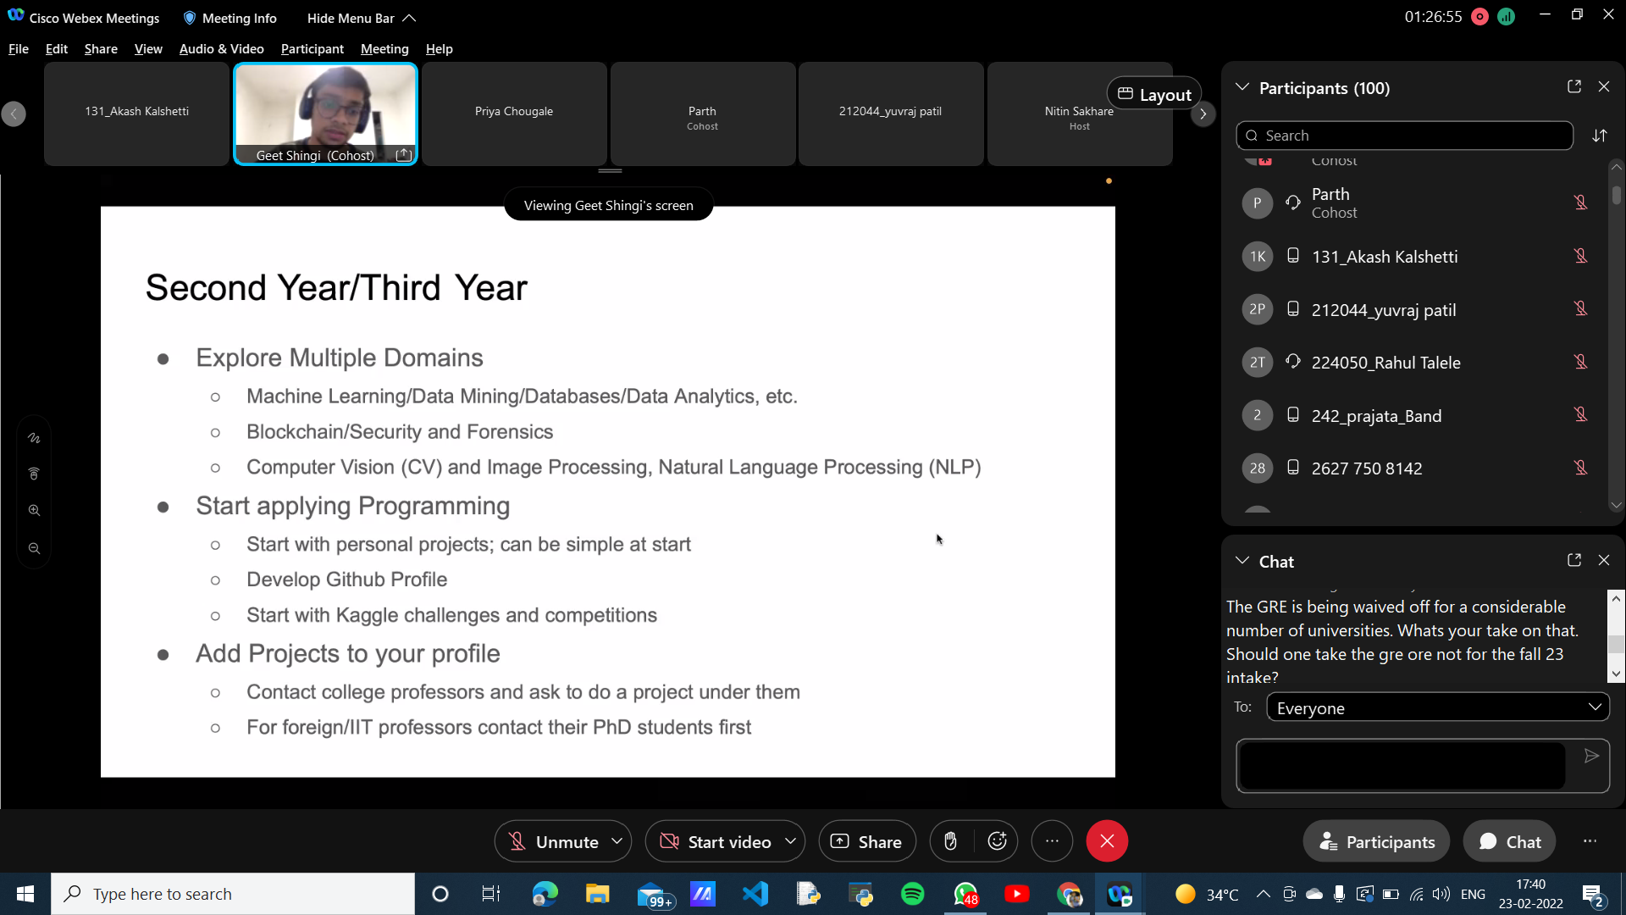

**“Passion to Profession”**

**24th February 2022:**

Passion certainly has no limits, and who better than Mr. Shubham Chatlawar to talk about his exciting journey. He has completed his bachelor’s from MIT Pune, and right after completion, he has been professionally associated in badminton. He is a National Level Badminton Player and also a certified NIS coach. Mr. Shubham talked about his entire journey and mentioned in detail all the challenges that he faced and how he tried to overcome them. Though our speaker was focused on sports, he was generous to mention generically so that all the participants can relate comfortably. The event helped youngsters learn from his experiences and the common mistakes that he committed. He also talked about the major turning points in his journey and how they turned out to be positive results. Gaining knowledge about the learning curve and various other similar concepts from Mr. Shubham was greatly appreciated by the participants.

